**What is Snowflake?**

**1: Data Platfrom**

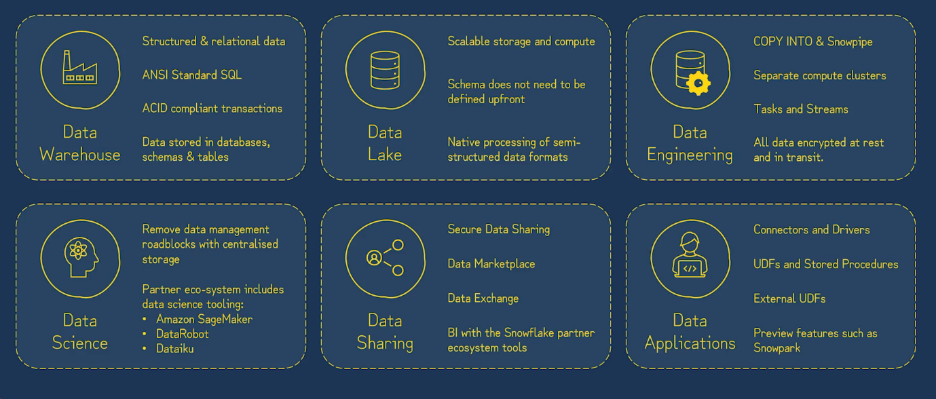

See the image

**2: Cloud Native:**

* Snowflake’s software is purpose built for the cloud
* All snowflake infrastructure runs on the cloud either AWS,GCP or Azure.
* Snowflake makes use of Cloud’s elasticity, scalability, high availability, cost-efficiency & durability.

**3: Software as a service(SaaS):**

* No management of hardware
* Transparent updates and patches
* Subscription payment model
* Ease of access
* Automatic optimization

**Data Warehouse Architecture:**

**Shared-Disk Architecture:**

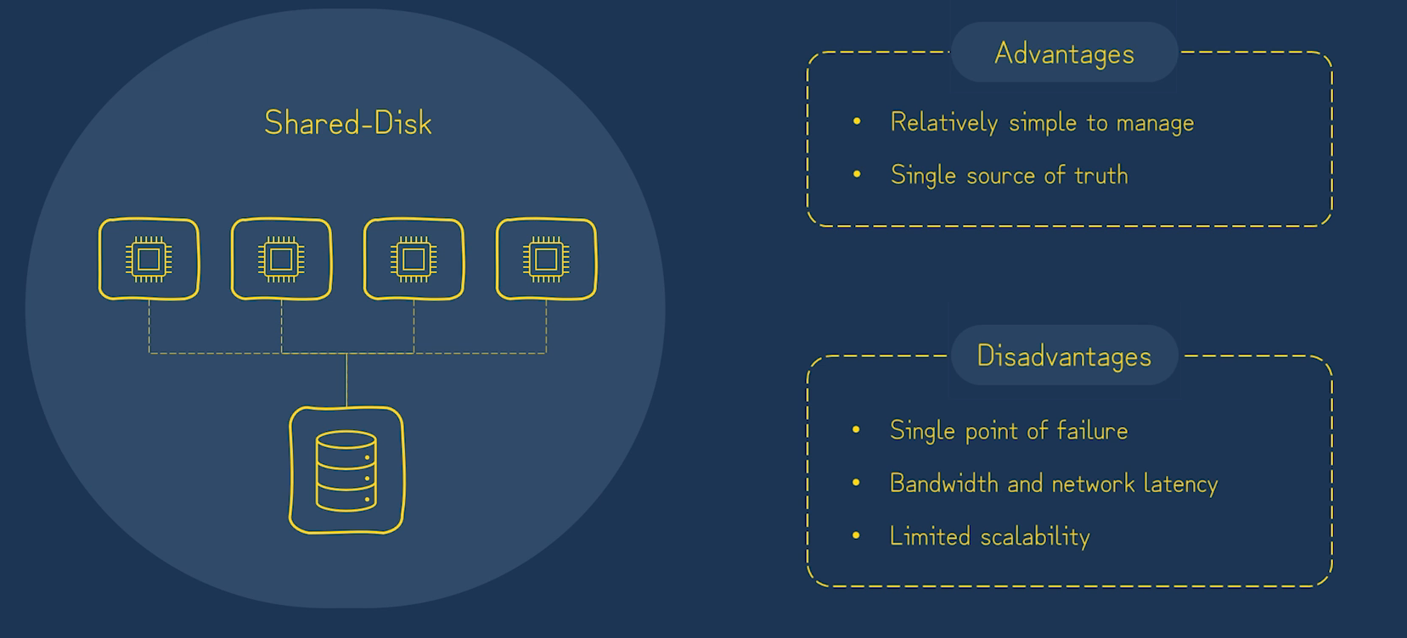

**Shared-Nothing Architecture:**

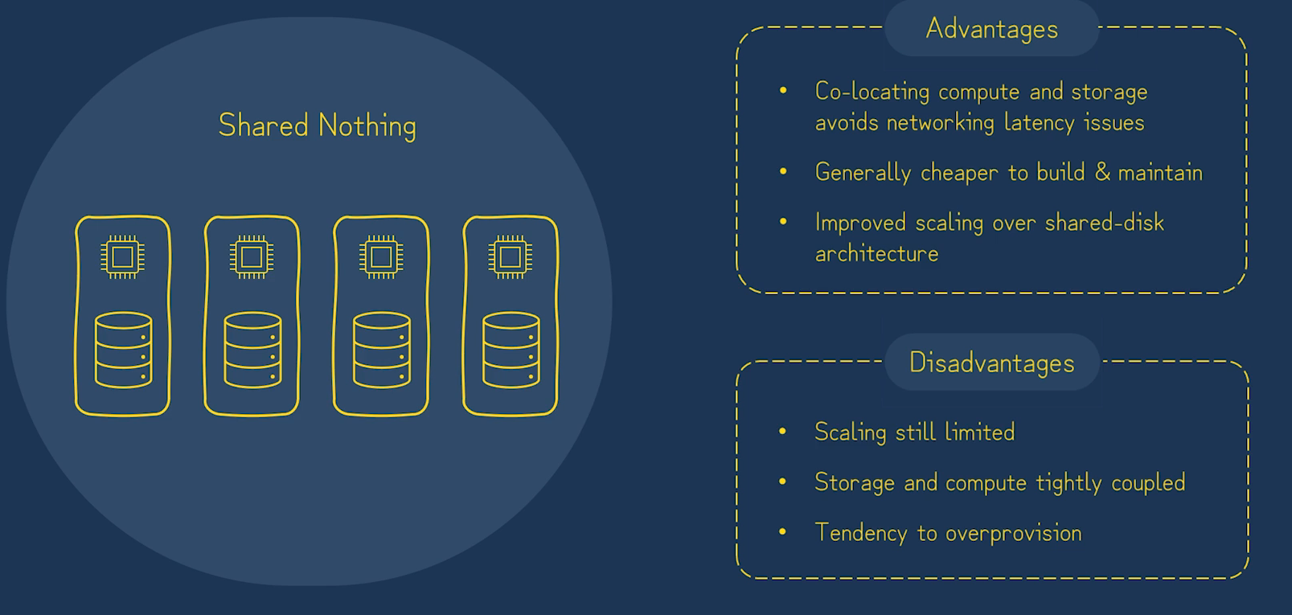

**Snowflake : Multi-Cluster Shared data Architecture:**

**Data Storage layer:** is shared disk architecture

**Query Processing Layer**: Shared Nothing Architecture

**Cloud Service** **layer**:

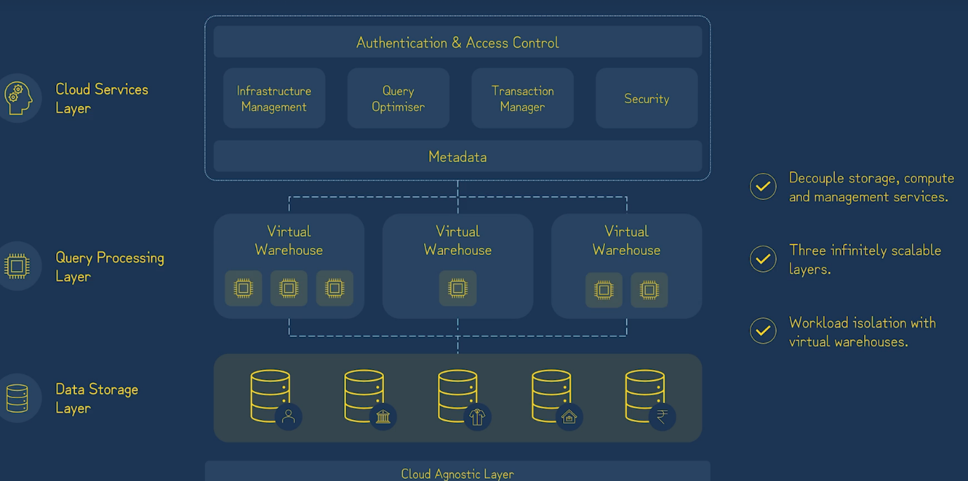

**Storage Layer:**

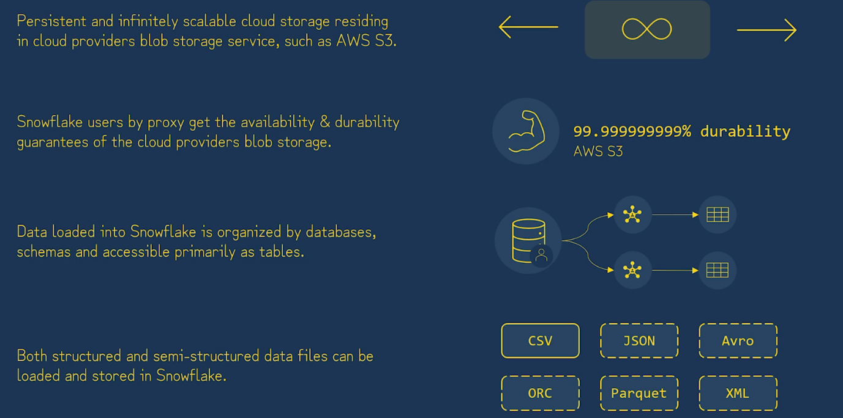

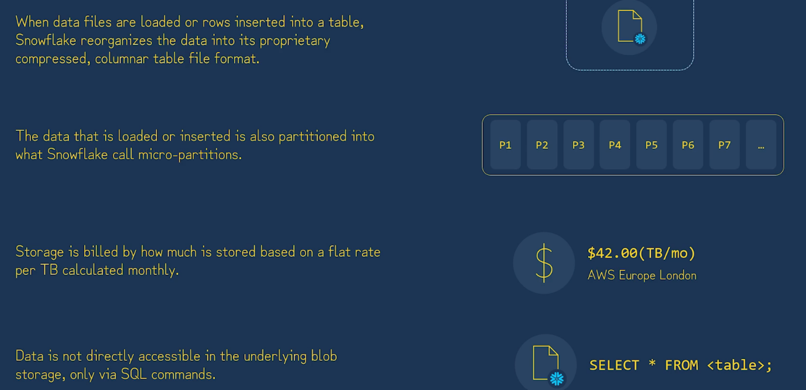

**Query Processing Layer:**

When we create give below command

CREATE WAREHOUSE WH_MY SIZE = LARGE;

It actually creates EC2 instance in distributed environment.

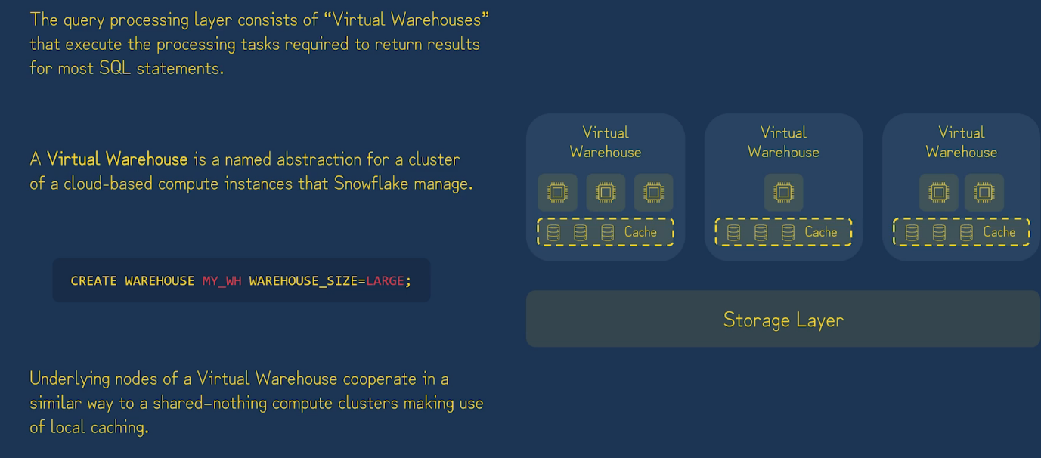

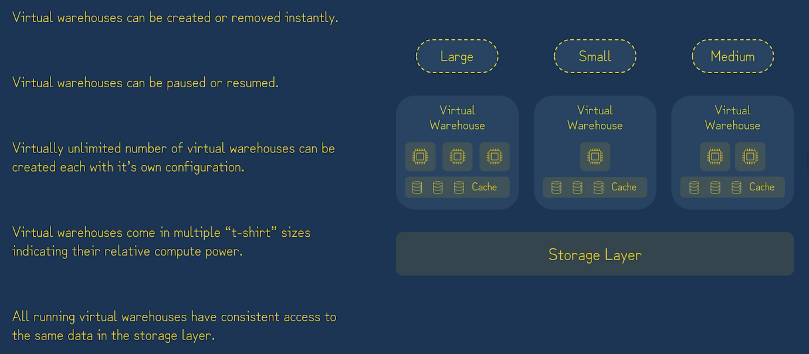

**Service-layer:**

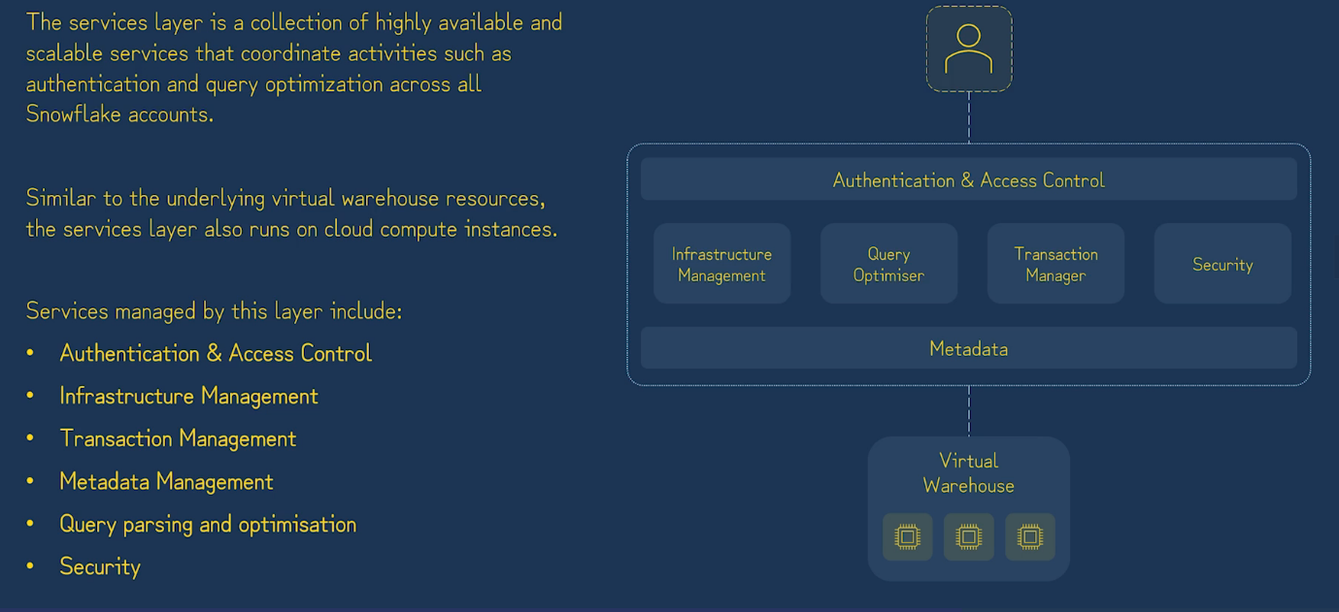



**Snowflake Edition & Key Feature:**

1. Standard
2. Enterprise Edition
3. Business Critical
4. Virtual Private Snowflake

**Snowflake Object Model:**

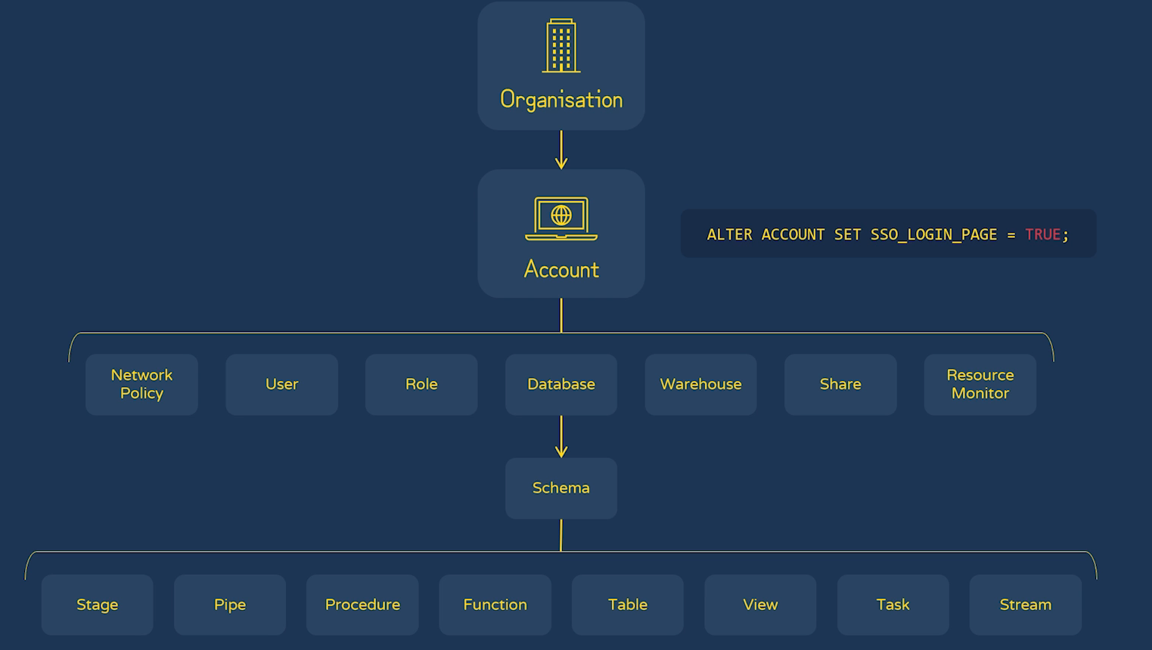

**Organization Overview:**

* Manage one or more Snowflake Account
* Setup and administer Snowflake feature which make use of multiple account
* Monitoring usage across accounts

**Organization Setup:**

* Contact Snowflake support
* Provide organization name and nominate an account
* ORGADMIN role added to nominated account.

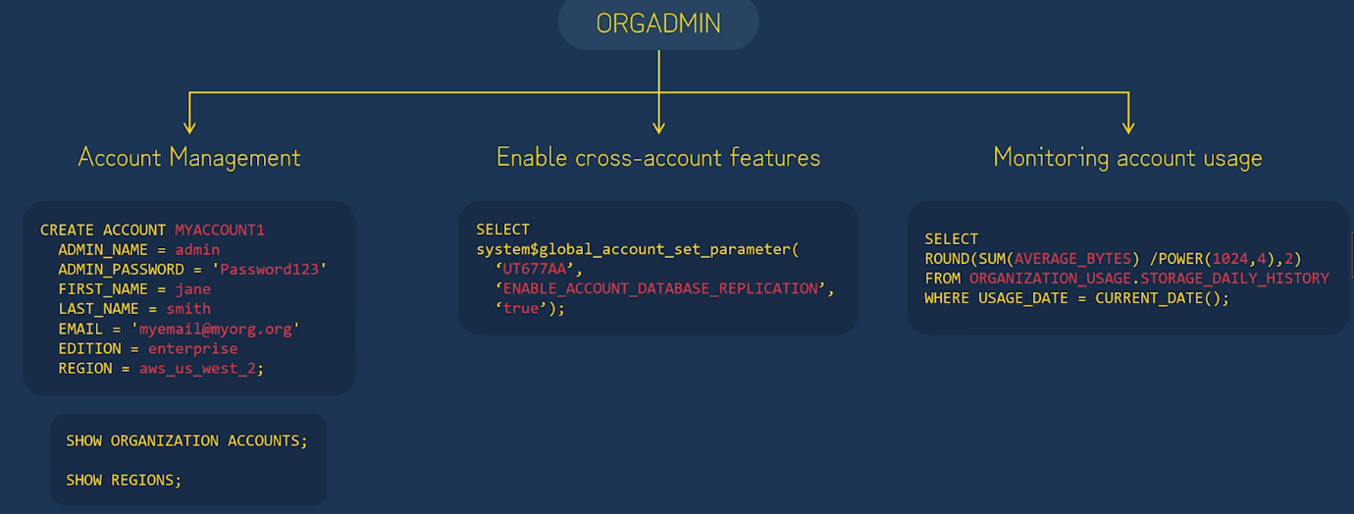

By default: 25 account is allowed to create.

**Account Overview:**

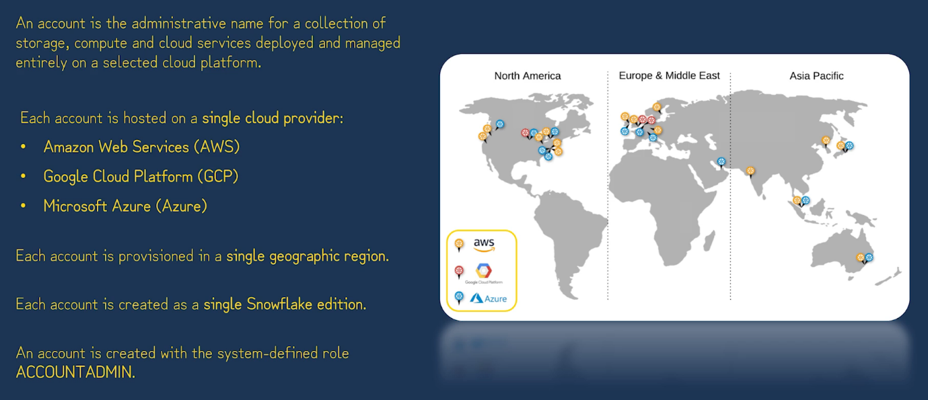

**Account URL:**

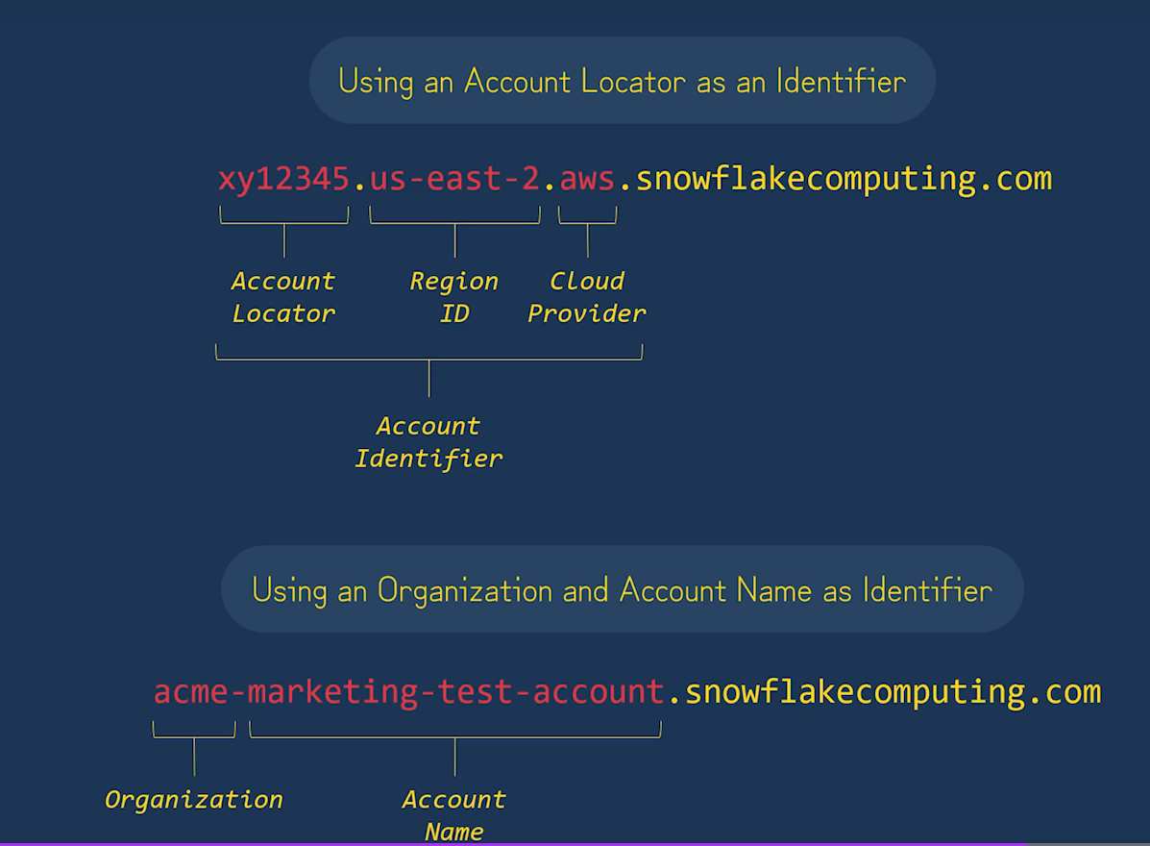

**Table Types:**

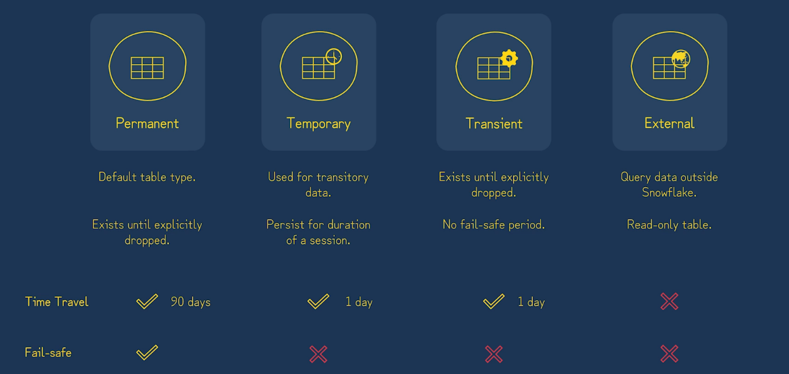

**View Types:**

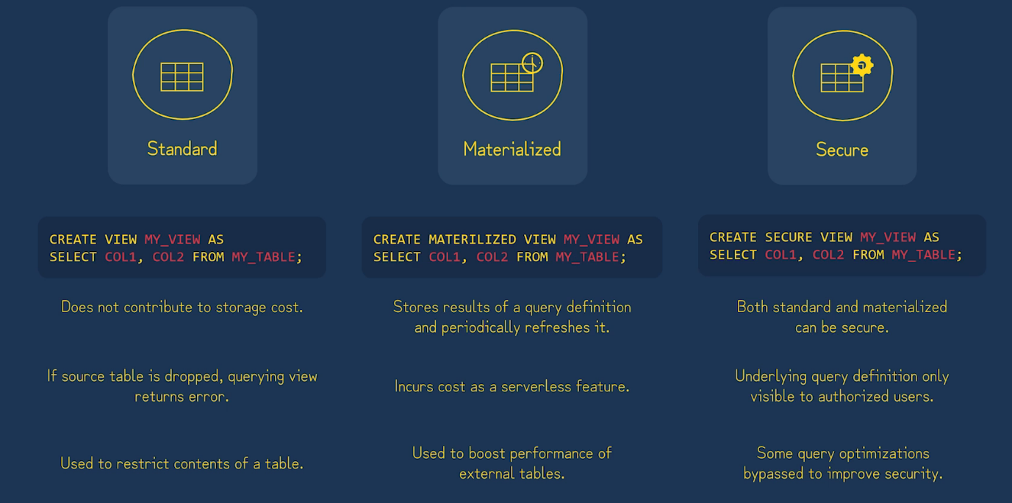

**User Defined Function:**

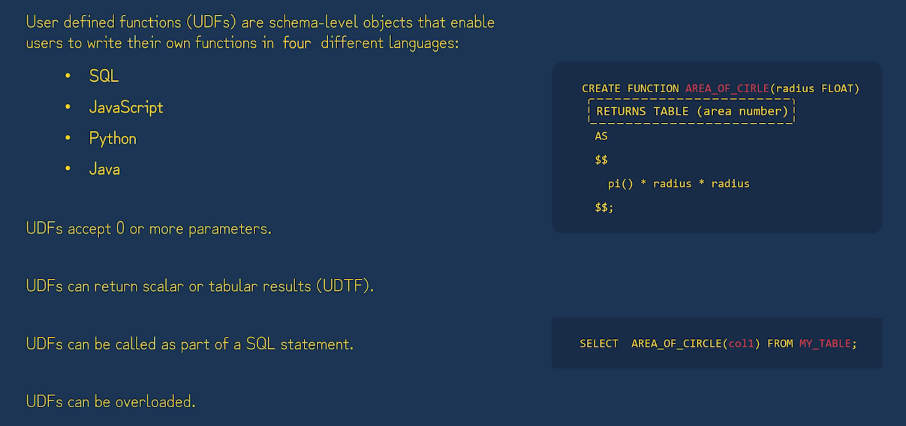

**External Function:**

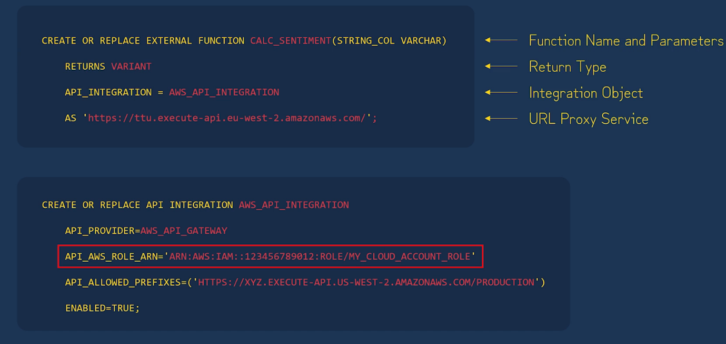

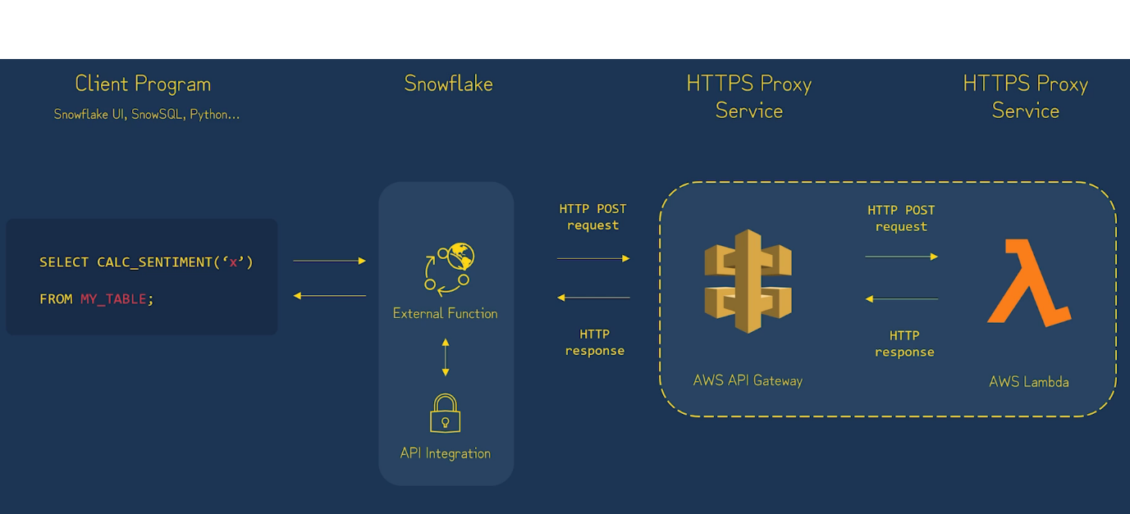

**External Function Limitation:**

* Slower
* Scalar only
* Not Sharable
* Less Secure
* Egress Changes

**Stored Procedure:**

t is a Database level object.

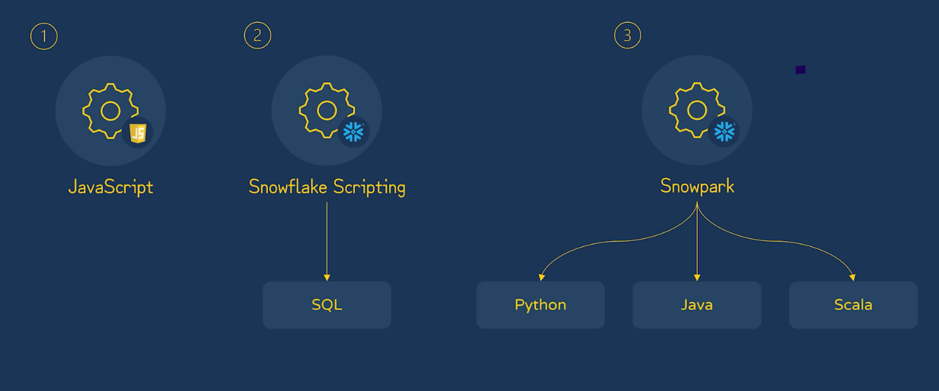

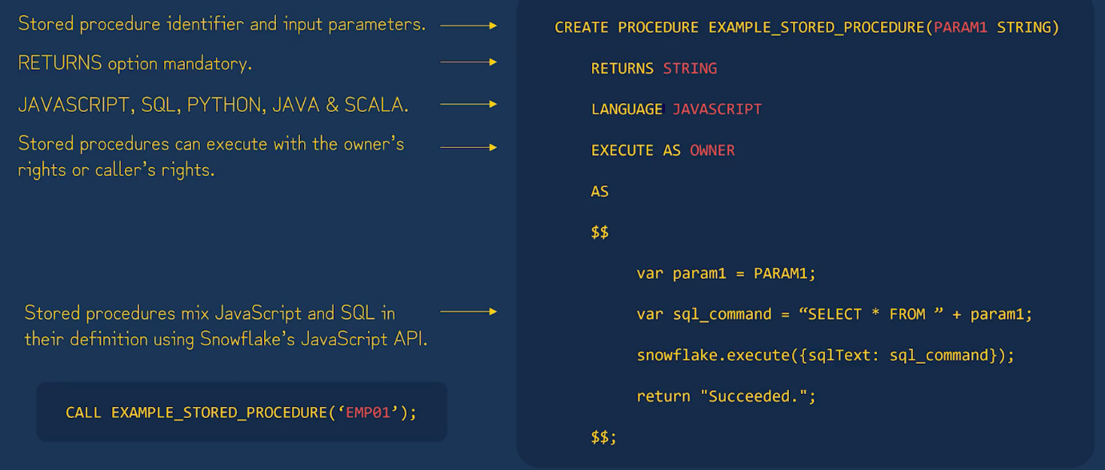

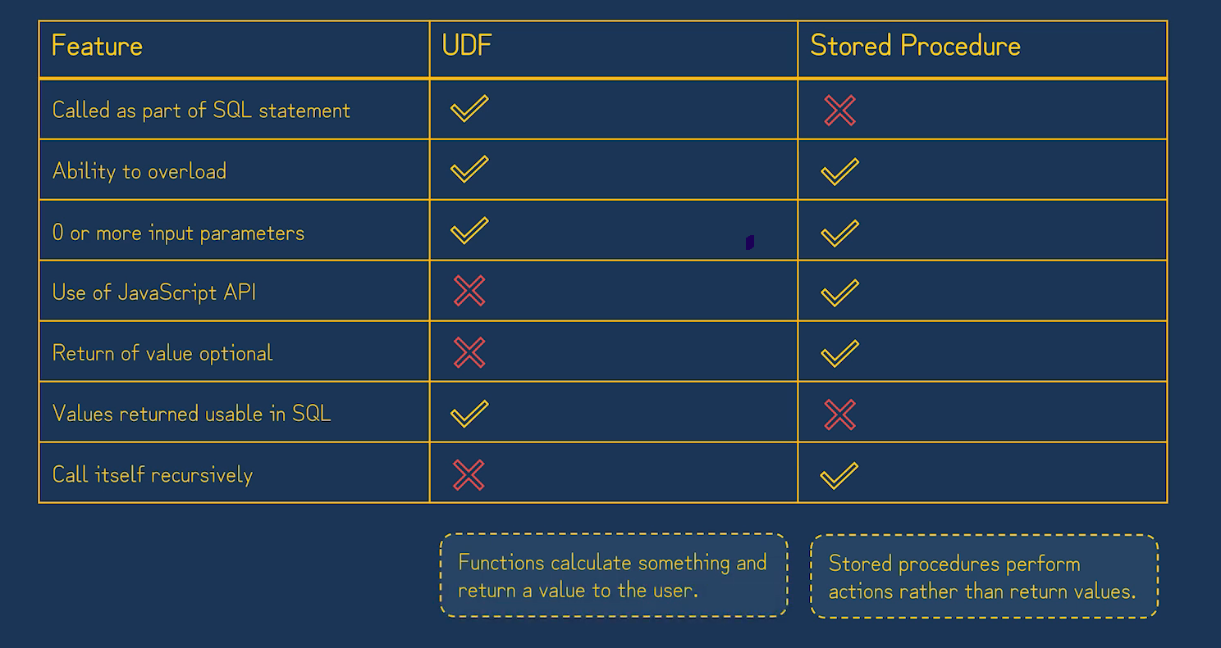

**SEQUENCE:**

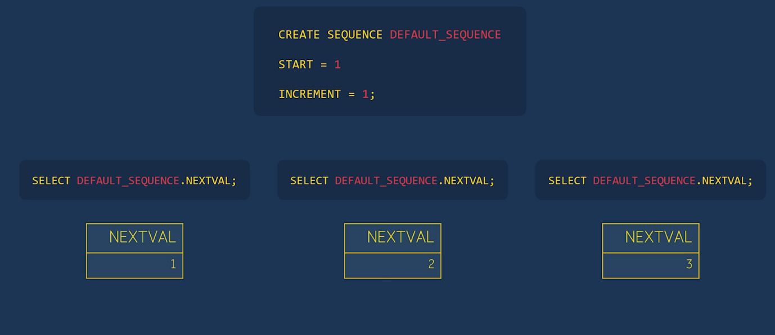

**TASK:**

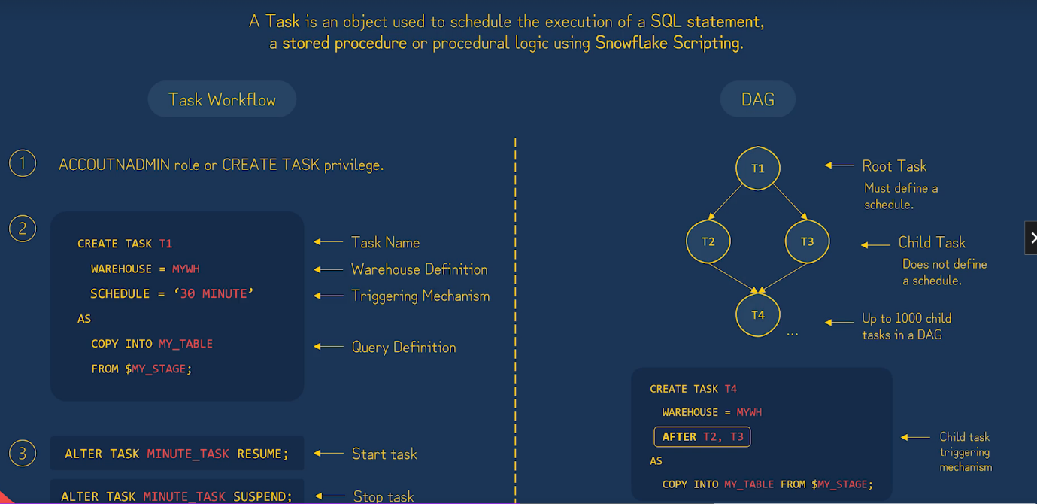

**STREAM:**

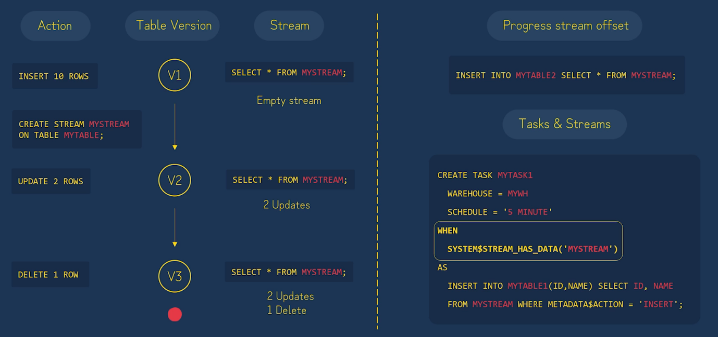

**Billing overview:**

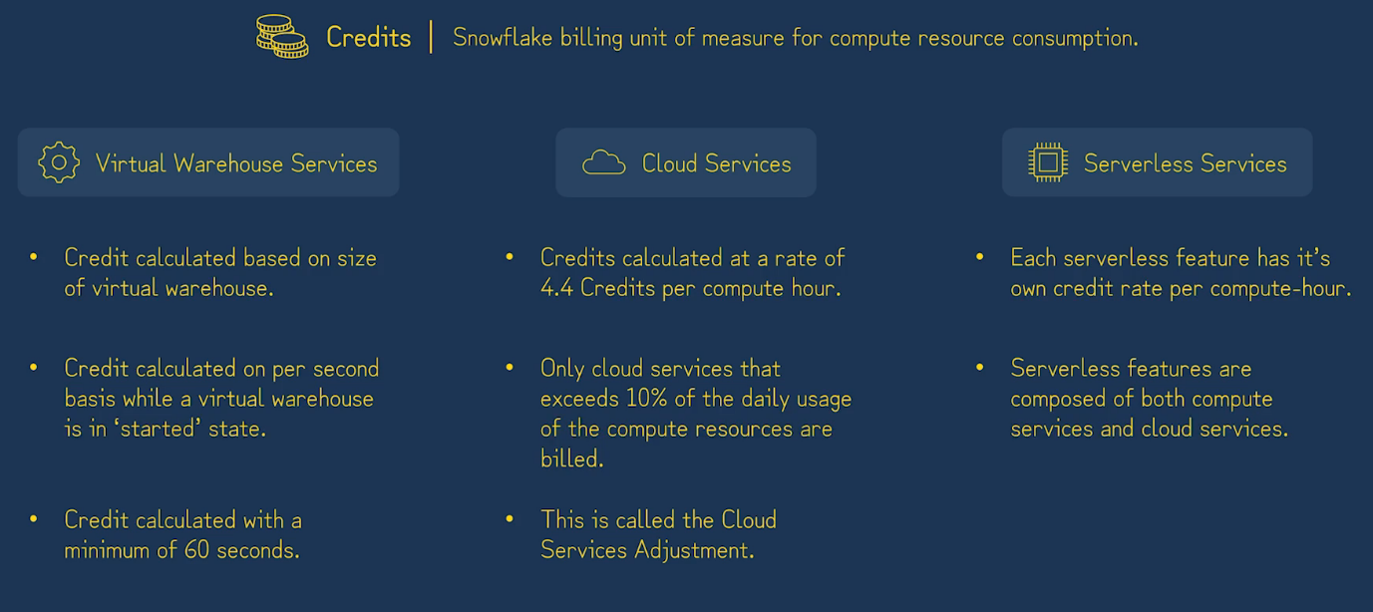

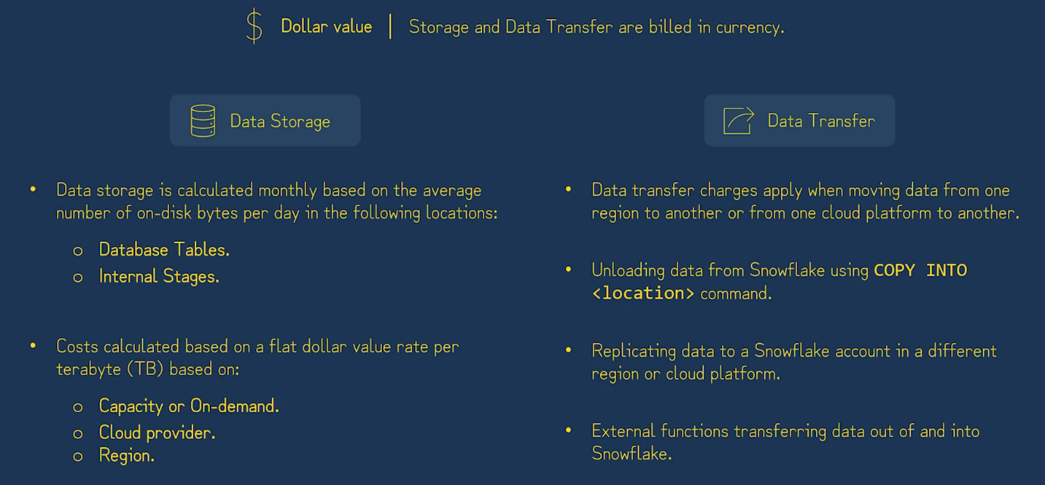

**Snowflake Partner Tool:**

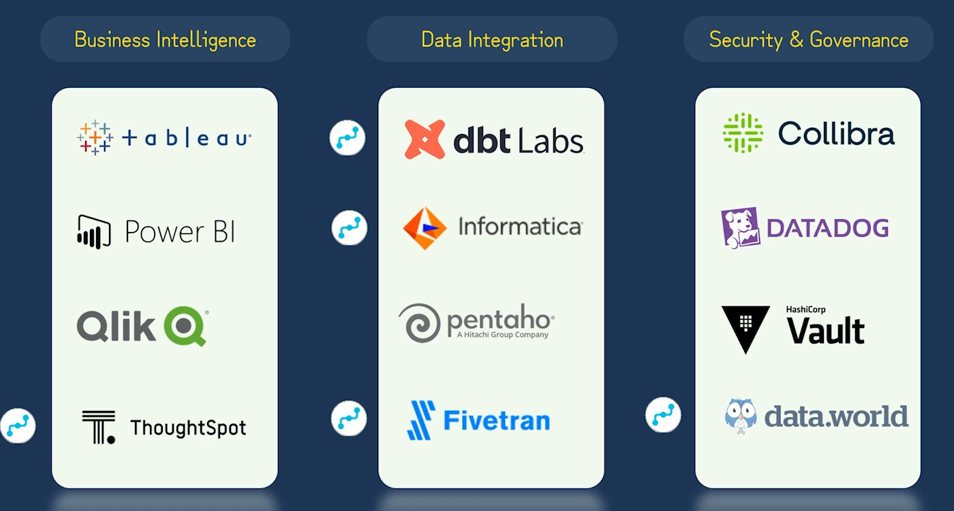

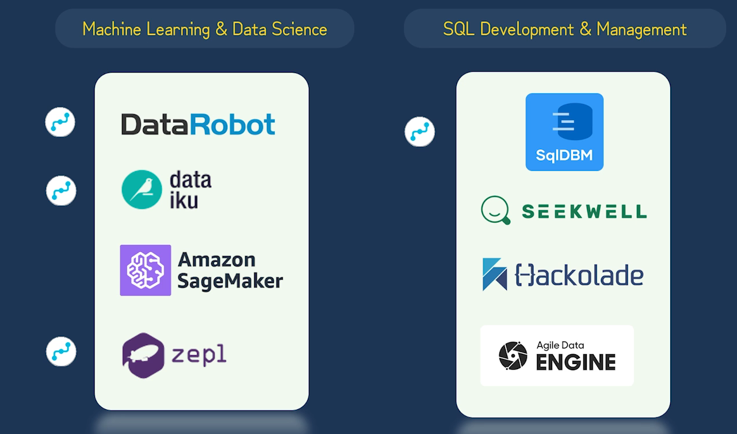

**Snowflake Scripting**

**Snowpark.**

